**Alouette 1 data restoration**

By : David Lessard

Internship Supervisor : Pierre Langlois

The purpose of this document is to record in a single location all the information concerning the data from Alouette 1 with the aim to facilitate the process of digitizing the data and their dissemination online (open data). This document focuses on Alouette 1’s primary mission, which was ionospheric measurements. No explanation concerning data interpretation or processing will be discussed.

**SUMMARY**

The Alouette 1 satellite was the first Canadian mission and the first Canadian satellite to have been sent out into space, launched on September 29, 1962. It collected data from the ionosphere up until 1972, despite the fact that at the time of its launch, the satellite was expected to last approximately 6 months. The mission was a success, and the Alouette 2, ISIS 1 and ISIS 2 satellites continued the mission undertaken by Alouette 1, which allowed us to collect large amounts of data about the ionosphere for almost 2 solar cycles (until March 13, 1984). The satellite had an orbital inclination of 80.5°, a period of 105.18 minutes, an altitude varying between 985 km and 1020 km as well as near-circular orbit. The collection of ionospheric data above telemetry stations. The satellite could not store data; it therefore had to be in range of one of the stations to be able to transmit data. The type of data collected by the satellite primarily concerned the science of the high frequency radio wave propagation through the ionosphere (topside sounding), but the satellite was equipped with various measurement instruments that made it possible to conduct other experiments, such as an energetic particle detector, a VLF (very low frequency) receiver and antennas for detecting cosmic radio noise.

The data were recorded at the stations on magnetic tape reels and were transcribed onto 35mm photographic film. During its passage, Alouette would transmit into the ionosphere a signal with a frequency varying between 0.5 and 11.5 Mhz over a period of 12 seconds. During this time, the satellite would cover a distance of approximately 80 km. An ionogram was taken at approximately every 18 seconds, thus the beginnings of the ionograms in a consecutive series were spaced 125 km apart. After approximately 10 minutes within range of the same station, the satellite would be automatically placed in standby mode. The coordinates at the beginning of every recorded satellite pass were stored on FILM LOGS associated with a specific station and were then transferred onto microfiche (to reduce the physical size of the sheets).

A first wave of digitization was performed under contract by the Canadian Space Agency. Reels 279 to 740 were digitized and placed on three 3 TB Seagate Backup Plus hard drives. These hard drives are currently at the John H. Chapman Space Centre in Saint-Hubert (Quebec).

**IONOGRAMS**

An ionogram is composed of 2 parts: its data and its metadata. The data are used and processed by scientists using a method developed by J.E. Jackson in 1969. It gives us information on the distribution of the electron density of the ionosphere according to the altitude. The metadata provide information on the time, date and location of the satellite at the moment when the data were collected. Ionograms can be found in 2 formats: binary metadata with a numerical interface and binary metadata with a punctiform interface:

8421

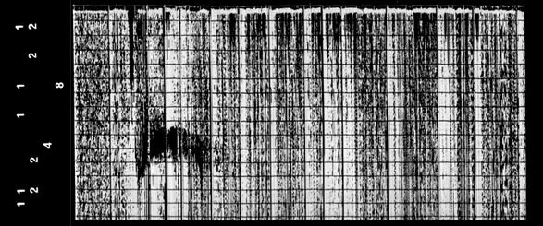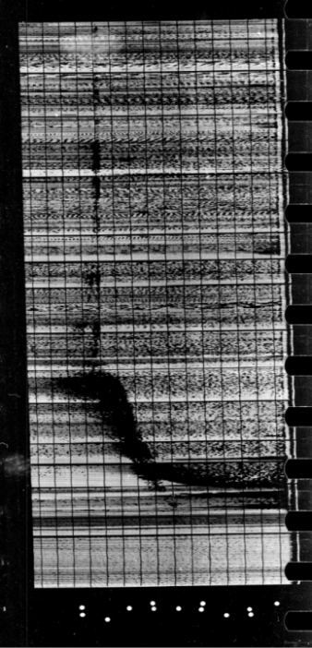

1248

Read this way

Read this way

**Binary format with numerical interface**  **Binary format with punctiform interface**

The y-axis (from top to bottom) represents the depth ranging from 0 to 1500 km (0 km is at the top of the axis and represents the satellite’s position) and the x-axis represents the frequency ranging from 0.5 to 11.5 MHz.

Meaning of the metadata (all the numbers on the same line must be added together):

1 2 4 8



Station number (1)

Seconds (46)

Minutes (23)

Time (23)

Day of the year (068)

84 21



UTC



Station number (03)

Seconds (02)

Minutes (09)

Times (01)

Day of the year (024)

Your 1960 + (3)

Satellite number (1)



UTC

As we can see with the punctiform format, there is no line reserved for the year of the ionogram. Knowing that prior to its launch the satellite’s anticipated life span was less than a year, I suppose that it was deemed unnecessary to include the year. This metadata format would thus indicate that the data were collected between September 29, 1962 and September 28, 1963. If the day of the year is between 1 and 271 inclusively, then the ionogram was taken in 1963, whereas for the days between 272 and 365, the ionogram was taken in 1962. We should look at reels from late 1963 to see if there are still any ionograms in the punctiform metadata format (an unconfirmed assumption, but quite probable and logical).

It is also possible that we may find a new ionogram format that I have not yet seen but that is mentioned in DATA USERS’ NOTE – ALOUETTE 1 (1962 BETA ALPHA 1) TOPSIDE SOUNDER by NSSDC (National Space Science Data Center). Figure 1 shows us what it looks like and how its metadata are interpreted:

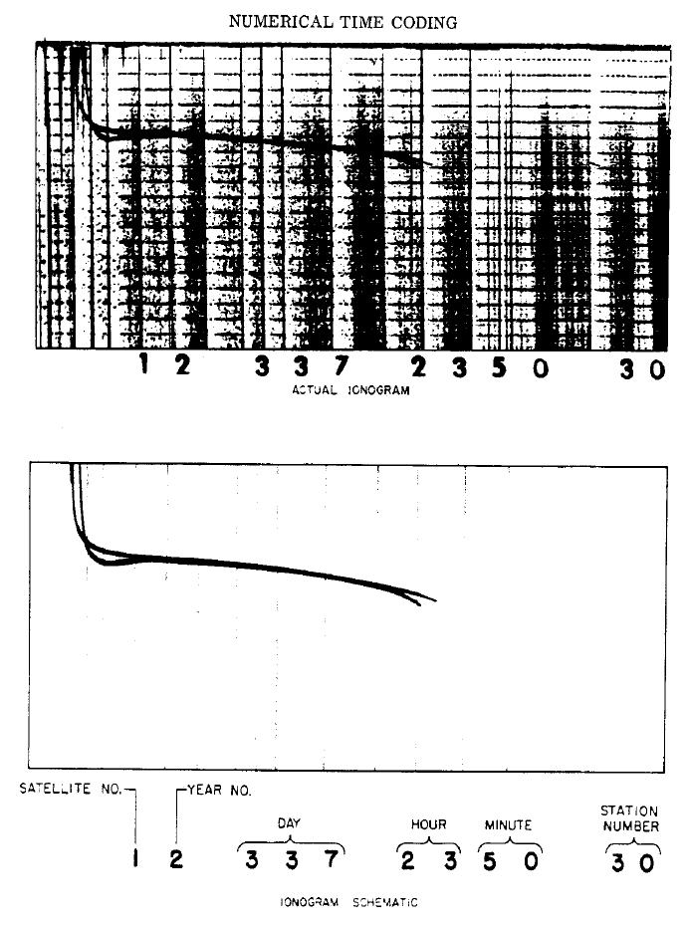Figure 1

The station number may be used with Table 1 to find the station (and location) where the ionograms were taken.

Table 1

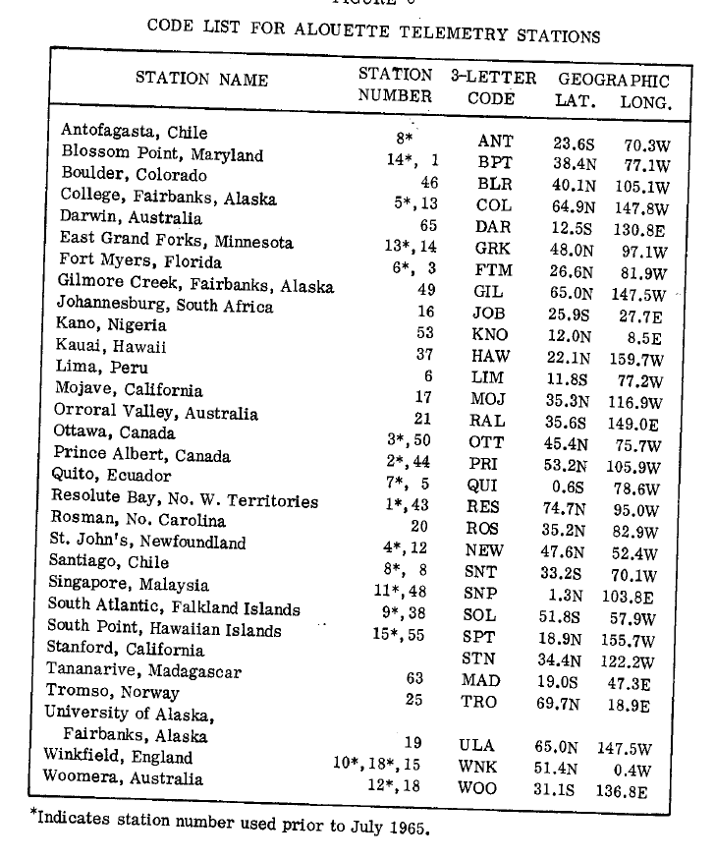

*Indicated the station numbers used before July 1, 1965.

Winkfield, England changed station number from 10 to 18 on April 25, 1963, until it was changed again to 15 on July 1, 1965.

This is the list of stations that we do not have on the list but that appear on the microfiches:

Station Name Station Number

Bretigny, France 71

Byrd Station, Antartica 51

Las Palmas, Canary Island 74

Kashima, Japan 70

Tromso, Norway 69

**REELS**

The reels group together the ionograms taken at the same station consecutively (in general). Some of the reels display ionograms in chronological order while others display them in inverse chronological order. We can also find ionograms from 2 different stations on the same reel or ionograms with numerical metadata that change into punctiform metadata (vice-versa). The numbers used to identify the reels are in the order in which they were created (see PROCESSED DATE on the microfiches). However, the date of the satellite’s pass is not related to the date when the 35mm reel was produced. Reel 279 is not necessarily more recent than reel 280, and consecutive reels do not necessarily contain consecutive ionograms. Occasionally, stations may alternate in a series of consecutive reels (419 is station 1, 420 is station 3, 421 is station 1, etc.). Also, it is possible for several reels in a series to provide information from one station, and that a reel from another random station appear in the middle of this series. This transcription is not in itself related to the data in any way, so the numbers that were attributed to the reels are of no significance.

A way to distinguish between two satellite passes, other than reading the metadata and finding two ionograms that are more than 105 minutes apart, is to identify the space between two ionograms directly on the reel. A few times, I found a space that could fit one to two ionograms in length. This assumption will have to be confirmed with more reels. Also, we can make a metadata reader, and we could also modify this program to separate the different satellite passes. It would probably be faster to use the 2nd approach if we would like to sort the satellite passes.

The reels appear to have been wound randomly. Even if we open the reels the same way, the ionograms will not all necessarily be positioned the same way.

Also, unusual ionograms can be found throughout the reels, but they are usually between 2 satellite passes. They contain metadata that are entirely unrelated to the passes they fall between. Furthermore, looking at the sequences of ionograms, we can see that the first ionograms have a weaker signal strength than the last ones. For example:

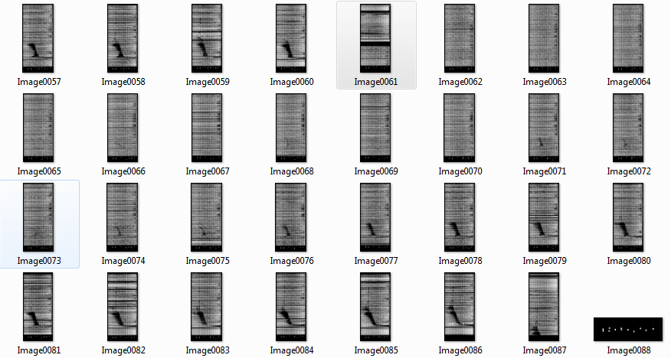

**MICROFICHES**

The microfiches group together the FILM LOGs (or also FILM LOG SHEETs) in chronological order according to the station where the ionograms were taken. The only exception is on the microfiche from Santiago, where the first FILM LOGs were taken in Antofagasta. The reason is that the station that was in Antofagasta closed on July 28, 1963 and was moved to Santiago, which opened on August 6, 1963. 72 microfiches are kept in Saint-Hubert, and each log that can be found on the microfiches is associated with a reel. Not all the reels can be found on microfiches (such as Resolute or Ottawa). Also, the type of metadata is not indicated on the logs. Here are 2 common examples of logs:

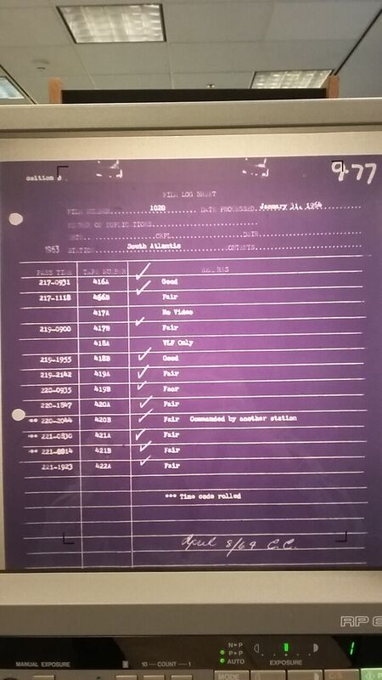 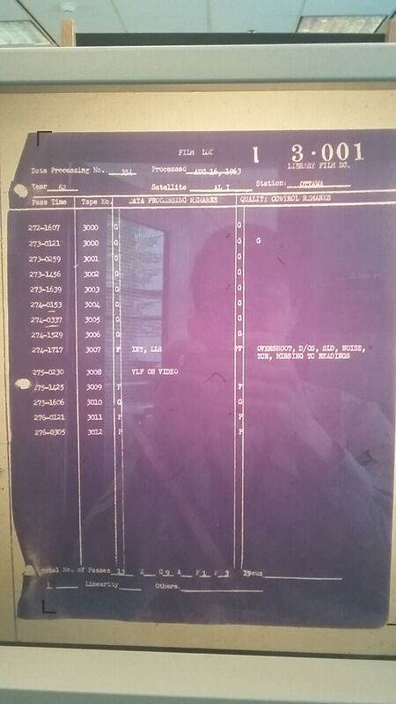

***An example of a FILM LOG SHEET on the left and an example of a FILM LOG on the right***

The type of log used depends on the date when the reel was created (PROCESSED DATE). From 1963 to October 1967, the FILM LOG SHEET was used. On the dates that come after October 1967, the FILM LOG was used. On some dates such as June 20, 1967, a FILM LOG was produced despite the fact that this was the period when the other type of log was normally used. On the FILM LOG SHEET, starting at the top left we find the **FILM NUMBER,** which is the identification number specific to the reel. On the right, **DATE PROCESSED** is the date when the ionograms that could be found on magnetic reels were transferred to 35mm reels. The terms **DRTE**, **CRPL** and **DSIR** do not provide information about the ionogram per se. They seem to represent institutes that participated in Alouette 1 (The Defence Research Telecommunications Establishment (DRTE), which is now Communications Research Centre Canada (CRC), Central Radio Propagation Laboratory (CRPL), also known as ITSA Institute for Telecommunication Sciences and Aeronomy (USA), and the Department of Scientific and Industrial Research (United Kingdom) (DSIR)). **STATION** provides the station where the data were collected. Directly above the table we can find **1963**, which represents the year when the data were collected. In the case where the data were collected during 2 different years (from late December to early January, for example), the year is written as follows: 1962-1963. **PASS TIME** describes the day of the year and the UTC time (ddd-HHMM) when the satellite began its pass. The same dates and times can be found on the first ionogram of a series of ionograms on the corresponding reel. Each row in the table corresponds to a satellite pass. **TAPE NUMBER** is a number specific to one station and represents the identification numbers of the satellite passes. This number cannot be found on the reel or on the ionograms. They are generally consecutive, which allows us to know if any satellite passes are missing on the FILM LOG SHEETs. For example, reel 444 at the Ottawa station contains a gap in its passes between days 87 and 92 (1963). As the TAPE NUMBERS between days 86 and 93 are not consecutive, I was able to determine that the data existed, but that they were on another reel. It was difficult to find these missing data as they were on reel 473, which is separated in 2 (from day 151 to 153 and, then, 87 to 92). As the TAPE NUMBERS corresponded perfectly with the gap that I was looking for, this confirmed that I had found the right passes. Furthermore, there is no logical relationship between the value of the TAPE NUMBER and of the PASS TIME. Its format can be numerical as it can be alphanumeric: 001, 001a, 001A. The case of the letter was chosen arbitrarily by the person that produced the FILM LOG SHEET. **REMARKS** provides information about the quality of the ionograms of the corresponding pass. A scale composed of five scores represents the quality (P,F,A,G and E, or Poor, Fair, Average, Good and Exact). Finally, more general comments on the reel are occasionally added in this column, under the last of the log’s passes. There is a table that provides the meaning of the acronyms. It can be found in the DATA USERS’ NOTE. We can often find the comments Last Film or Station Closed on the last log produced by a station. Finally, right in the top-right corner of the log, there is an identification number (called LIBRARY FILM NO. on the FILM LOG) **9-77** of the FILM LOG SHEET. 9 represents the station number, while 77 indicates that it is the 77th FILM LOG SHEET, in chronological order, starting from station 9 (South Atlantic). When it isn’t written by hand, there is a “I” (like in the FILM LOG), which refers to Alouette 1. If it was an Alouette 2 log, there would be a “II” instead.

With regards to the FILM LOG (the image on the right), the only deferences is that the **Data Processing No.** line replaces FILM NUMBER. A section entitled **Satellite** was also added, confirming that they are Alouette 1 microfiches. Finally, the table’s REMARK column was replaced by **DATA PROCESSED REMARKS**  and **QUALITY CONTROL REMARKS**, each with a thin column reserved for the score (according to the scale mentioned earlier). Here is a list of acronyms that can be found in these columns:

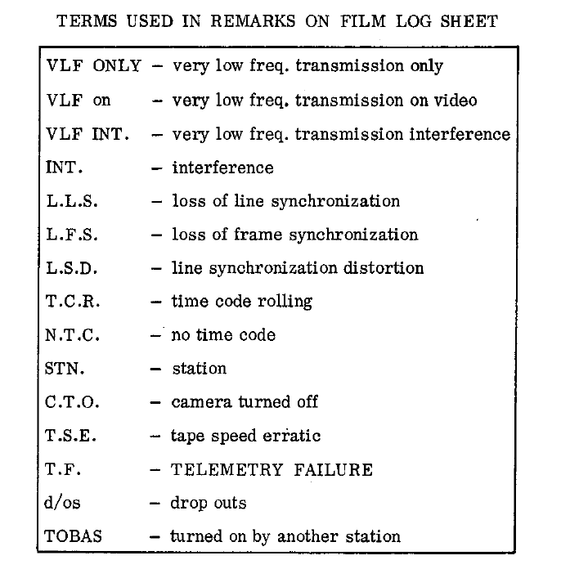

At the bottom, a line displays a summary of the scores found in QUALITY CONTROL REMARKS. We also find new sections right at the bottom of the log, which also describe the quality of the ionograms, but their meaning has not been determined.

In the pile of microfiches that I have, there are stations for which approximately 200 logs are missing. Not all the logs were recorded on the microfiches that I have in my possession. For example, the first 200 logs from Resolute Bay are missing. Some are missing from Ottawa as well, where the **LIBRARY FILM NOs.**. jump from 3.199 to 50.400 (the station number jumps from 3 to 50), therefore 200 logs are missing from Ottawa. There are probably other stations that are missing logs, because for several stations, the comments LAST FILM and Station Closed are not found, suggesting that some of the logs were not stored on microfiches. The examples are Quito, Resolute Bay, Singapore and St. John’s.

A particular case encountered with the microfiches appeared with the station in Singapore, where RSRS PROCESSING was found next to the PROCESSED section. Normally, we expect to have a date at this location, but this message is there instead. R.S.R.S. refers to the Radio and Space Research Station, Slough, England, which is one of the main laboratories of the Science Research Council (S.R.C.) in the UK that worked on Alouette-ISIS. It is highly probable that the 35mm reel was produces at this location, as Singapore had previously been an overseas territory of the British Empire.

Here is a list that shows the stations’ lifetimes. The dates in green are dates that have not been confirmed, and that may be wrong:

Station Opening Closing

Antofagasta, Chile* 272 (1962) 209 (1963)

Blossom Point, Maryland 272 (1962) 266 (1965)

Boulder, Colorado 25 (1966) 347 (1971)

Bretigny, France 206 (1967) 37 (1972)

Byrd Station, Antartica 42 (1966) 306 (1967)

College, Fairbanks, Alaska 272 (1962) 283 (1966)

East Grand Forks, Minesota 49 (1963) 181 (1966)

Fort Myers, Florida 273 (1962) 179 (1970)

Johannesburg, South Africa (No reel on microfiche)

Kano, Nigeria 246 (1964) 299 (1966)

Kashima, Japan 227 (1966) 301 (1968)

Kauai, Hawaii 222 (1965) 306 (1969)

Las Palmas, Canary Island 334 (1967) 82 (1968)

Orroral Valley, Australia 327 (1965) 178 (1970)

Ottawa, Canada 272 (1962) 314 (1972)

Ouagadougou, Burkina Faso 223 (1967) 53 (1972)

Prince Albert, Canada 273 (1962) 235 (1963)

Quito, Ecuador 273 (1962) 309 (1965)

Resolute Bay, No. W. Territories 295 (1963) 264 (1965)

St. John’s, Newfoundland 273 (1962) 222 (1967)

Santiago, Chile 218 (1963) 354 (1965)

Singapore, Malaysia 135 (1968) 331 (1969)

South Atlantic, Falkland Islands [Port Stanley] 273 (1962) 51 (1972)

South Point, Hawaiian Islands 311 (1962) 161 (1965)

Tromso, Norway 228 (1966) 87 (1972)

University of Alaska, Fairbanks, Alaska 333 (1965) 180 (1970)

Winkfiled, England 272 (1962) 179 (1970)

Woomera, Australia 273 (1962) 304 (1965)

* Note: Antofagaste does not have any microfiche in its name. The FILM LOG SHEETs are collected on the first microfiche from Santiago.

The microfiches have been digitized. They are in one document, named using the following format: SSS-###. The first three characters represent the name of the station and the last three represent the log number (see LIBRARY FILM NO.). The microfiches are named as SSS-000-#. When more than one microfiche groups together all the logs from one station, the last character identifies their order. If two logs at the same station have the same LIBRARY FILM NO., they are numbered as SSS-###-#, where the three numbers represent the log number and the last number indicates their order. The reason why 2 logs can have the same LIBRARY FILM NO. is that occasionally one log is not big enough to contain all the information from a reel.

Here is the list of logs on the microfiches that are potentially missing (Last Film or Station Closed are not indicated on the last log of the microfiches of this station where there is a jump in the LIBRARY FILM NO.). :

* College (logs 400 to 599)
* Ottawa (logs 200 to 399)
* Quito (logs 200 and over)
* Resolute Bay (logs 001 to 199 and 600 and over)
* St.John’s (logs 200 and over)

**ALREADY PROCESSED DATA (INVERTED TO ELECTRON DENSITY)**

<https://spdf.gsfc.nasa.gov/pub/data/alouette/topside_sounder/crc_ne_profile_ascii/>

On this site, there are ionograms that have been inverted to electron density profiles There have been three waves of digitization (Alouette a, b and c) whose specifications are as follows:

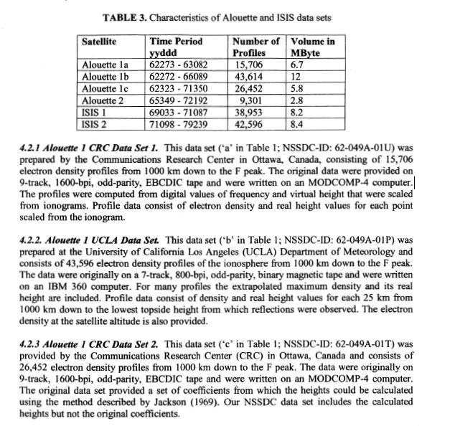

These data were assembled in Excel documents named “alouette_ne_a,” “alouette_ne_b” and “alouette_ne_c,” and the original data were copied and pasted into the document “Raw Data (all).”

**PREVIOUS DIGITIZATION**

During the first wave of digitization of the ionograms, reels 279 to 740 were digitized (boxes R014207907, R014207908, R014207909, R014207929, R014207930, R014207940, R014207978 and R014207979), thus covering the period from September 1962 to September 1963. The images are saved in TIFF format and take up 36MB on average and are distributed across three 3TB hard drives. The immensity of the images is going to be a problem when it will be time to place the data online. The ionograms are vertical with the metadata at the bottom. An error arose in the ionograms with numerical metadata; the ionograms are paired with the wrong metadata. Here is an image that demonstrates the error:

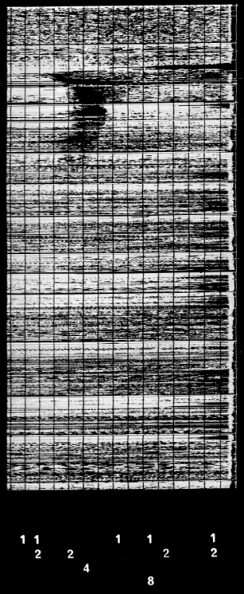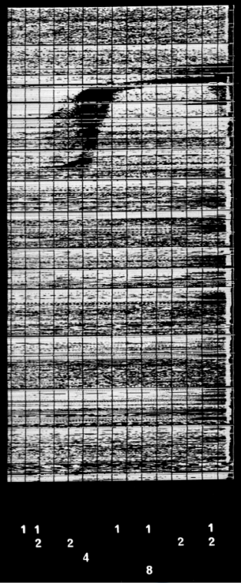

Targeted ionogram

Metadata used

True metadata

The image outlined in red is as it is found on the hard drive. However, the DATA USERS’ NOTE states that the metadata associated with the ionogram are supposed to be to the left when the ionogram is positioned this way.

**CORRECTIONS**

As the resolution is very high, I converted the images from hard drive #1 of 3 into PNG format and reduced the resolution by 36: 1. The new format of the images allows for a lossless compression, which made it possible for us to reduce the average size to 350KN. I determined that this was the size that would allow for the greatest reduction in size while still preserving the important information of the ionograms. Furthermore, I positioned all the ionograms in the same way, that is, horizontally with the curves (trace-X and trace-O) always pointing in the same direction. I also realigned the metadata of the ionograms with numerical metadata with their original ionograms. Finally, I created a text document named “ListOfChange.txt,” which describes which changes were made to which images. This makes it possible to track if an image has been reconstituted with the metadata of another image or if it has been deleted because the ionogram was useless.

**RECOMMEDNATIONS FOR A FUTURE DIGITIZATION**

Here are the important criteria to know about the ionograms to ensure that the same errors are not reproduced:

* PNG format (lossless compression)
* 8 bits of colour (grey)
* Resolution is approximately 67 dpi (see previously produced images)
* Group together the ionograms per reel in one electronic file.
* Group together the reels from one box in an electronic file that adopts the name of the box (a box identification number resembles R014207979, for example).
* The image must be positioned horizontally with the metadata on the left (following this model):



As the curve is not always present, one can rely on the thin black strip that should be at the top. With the ionograms with numerical metadata, the positioning is easy to determine (the numbers have to be facing as demonstrated above). For the punctiform metadata, it isn’t as obvious. Try to find the strip (it can be very easy to find and very difficult to identify, but usually, it is always present):

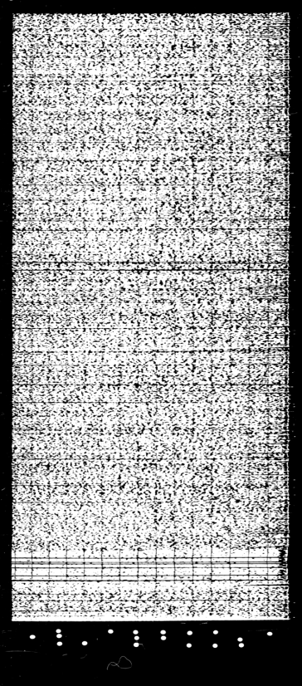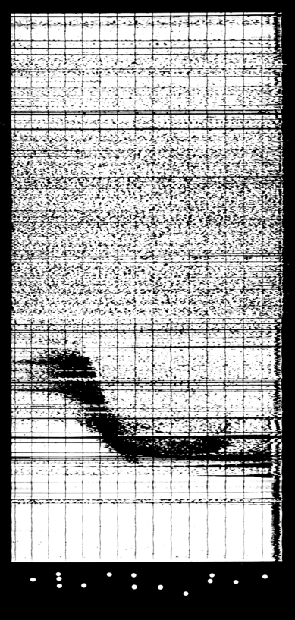

It should be mentioned that this thin strip is never at the bottom of the ionogram. Also, this strip is transparent on the reel (the images above were digitized and the colours inverted). As long as the strip is at the top and that the closest punctiform metadata are to the left, the ionogram and all those on the same reel will be properly positioned. The following explains what I mean by the closest punctiform metadata:

Bad example (strip positioned correctly, closest metadata positioned incorrectly):

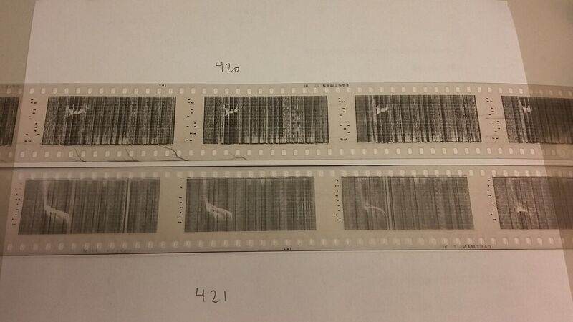

Good example (strip positioned correctly, closest metadata positioned to the left):



The curve is going the right way, which confirms that the positioning is correct.

In short, the positioning of the ionogram can always be verified by ensuring that the curve is positioned like in the examples given. In the case of numerical metadata, we can position the ionograms with the numbers facing the following direction:. Finally, in the case of an ionogram with punctiform metadata, we should ensure that the thin black strip is at the top AND that the closest metadata are to the left of the ionogram. The reel must be unwound until an ionogram that meets at least one of these three conditions is found.

1 2

**LIST OF UNSOLVED MYSTERIES**

Assumptions to be confirmed:

* Among the sections at the bottom of the ionogram, here are the assumptions about their meaning:
  + (or *Perpendicularity*) = the perpendicularity of the graduations on the ionograms
  + *Linearity* = refers to the calibration between the measurements and the grid/uncertainties
  + *Focus* = If the curves are dispersed or concentrated (see the following example):

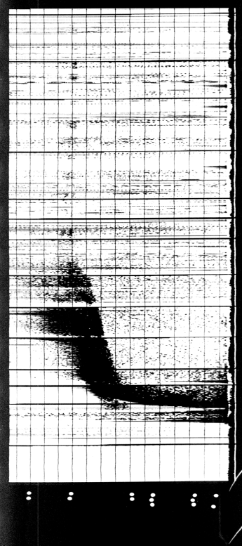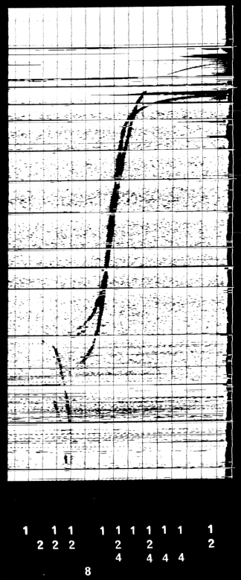

* + *Others* = For any additional comment
* The reel numbers begin with the number 279, because the first 278 are from Singapore. According to the DATA USERS’ NOTE, the station in Singapore opened its doors on September 30, 1962. On the microfiches, there is a note that states that the logs dated prior to 1967 did not contain any metadata, so we weren’t able to produce any microfiches with these reels. However, we seem to have found reels 12 to 20 on the microfiches from Singapore, which date back from 1967.

Unanswered questions

* Questions related to microfiches:
  + The logic behind the TAPE NUMBERs (why some are 001a, 001b and others just 001, 002, why Ottawa starts at 3000, etc.). This is what is known:
    - They are not related to the PASS TIME (within one day they go from 415B to 417B and not 415A to 415B as would be expected). They go from 419A to 419B with days 295 to 296 (examples taken from the previously shown microfiche).
    - Furthermore, on other reels, it is clear to see that the TAPE NUMBER does not refer to the satellite pass either (2 consecutive TAPE NUMBERs do not represent 2 consecutive satellite passes).
    - On reel 1020 from the South Atlantic station, there are 2 locations where 2 TAPE NUMBERs are associated with the same PASS TIME.
  + The meaning of the notations in the top left corner of the logs, such as AAA, BBB, Position A, Position B (related to the PROCESSED DATE?):
    - The 4 never appear together (always one of the 4)
    - When it is on a FILM LOG with the *Satellite*_____ section, there are never notations at the top left. However, I found AAA on the line next to *Satellite*, but never BBB, or Position A/B. At times, on this line, AAA is replaced by AL1.
    - I thought that this referred to the satellite used, but they are all ionograms from Alouette 1 (as far as I know), so I don’t understand why some are BBB, especially since BBB never appears in the Satellite section...
    - The notations BBB and Position B appeared before Alouette 2 was launched, so it wouldn’t make much sense if they would refer to the satellite.
    - On the Alouette 2 microfiches, I noticed BBB AL2, so clearly, BBB does not refer to the identification of the satellite.
* Why some ionograms have numerical metadata and others use punctiform metadata. It is possible that there is a connection between the types of metadata and the types of logs.

**EXTERNAL REFERENCES RELATED TO THE MISSION**

* DATA USERS’ NOTE – ALOUETTE 1 (1962 BETA ALPHA 1) TOPSIDE SOUNDER

<https://spdf.gsfc.nasa.gov/pub/data/alouette/sweep-frequency_sounder/ionogram_indexing_dusted_echoes/alouette1/alouette1-2_isis1-2_index-ducted-echoes_62-049a-01a_65-098a-01n_69-009a-01e_71-024a-01e_DSC_0243.pdf>

* Alouette/ISIS Date Restoration Project (emphasis on ISIS)

<https://spdf.gsfc.nasa.gov/isis/isis-status.html>

* Digitization of ionograms:

<https://www.researchgate.net/publication/237386918_RESCUING_IONOGRAM_FILM_ARCHIVES_AT_WORLD_DATA_CENTERS_FOR_THE_IRI_AND_POSTERITY>

* Reading and analysis of the ionograms:

<ftp://ftp.ngdc.noaa.gov/ionosonde/documentation/UAG_23A_Searchable.pdf>

* TOPIST (1st source):

<https://ntrs.nasa.gov/archive/nasa/casi.ntrs.nasa.gov/20050194578.pdf>

* TOPIST (2nd source):

<https://nssdc.gsfc.nasa.gov/space/isis/documents/papers/topist_rs_final.pdf>

* Alouette 1 inverted ionograms

<https://spdf.gsfc.nasa.gov/pub/data/alouette/topside_sounder/crc_ne_profile_ascii/>

* Explanation of the ionosphere/studies related to the ionosphere

<https://ntrs.nasa.gov/archive/nasa/casi.ntrs.nasa.gov/19650022493.pdf>

* Understanding Alouette 1 data (very relevant)

<https://ntrs.nasa.gov/archive/nasa/casi.ntrs.nasa.gov/19630013798.pdf>

* Understanding ionograms

<http://onlinelibrary.wiley.com/doi/10.1029/2005RS003352/pdf>

* Interpretation and reducing ionograms

<ftp://ftp.ngdc.noaa.gov/ionosonde/documentation/UAG_23A_Searchable.pdf>

* Previous ionogram digitization mission

<https://www.researchgate.net/publication/237386918_RESCUING_IONOGRAM_FILM_ARCHIVES_AT_WORLD_DATA_CENTERS_FOR_THE_IRI_AND_POSTERITY>

* Old detailed article on the Alouette mission (p. 456-458)

[https://books.google.ca/books?id=5wc7kDlHFlEC&pg=PA458&lpg=PA458&dq=boulder+telemetry+station&source=bl&ots=NWPzEm5Xzg&sig=UbhU5mX0oOG6ORpL6M1T2ueqFMU&hl=en&sa=X&ved=0ahUKEwjthbDIqafUAhXqqlQKHTwEAjYQ6AEIYTAJ#v=onepage&q&f=false](https://books.google.ca/books?id=5wc7kDlHFlEC&pg=PA458&lpg=PA458&dq=boulder+telemetry+station&source=bl&ots=NWPzEm5Xzg&sig=UbhU5mX0oOG6ORpL6M1T2ueqFMU&hl=en&sa=X&ved=0ahUKEwjthbDIqafUAhXqqlQKHTwEAjYQ6AEIYTAJ#v=onepage&amp;q&amp;f=false)